Git upload

1. Clone from a repository
2. Create a branch
3. Commit changes
4. Pull requests

Github Desktop is very helpful.

How to connect remote server (e.g. Federation) with VS Code:

1. Prerequisites

* VS Code
* Remote SSH extension in VS Code
* ssh identification file
  + Such as the private key ~/.ssh/id_rsa in mac.
  + Refer to [4.3 Git on the Server - Generating Your SSH Public Key](https://git-scm.com/book/en/v2/Git-on-the-Server-Generating-Your-SSH-Public-Key) to generate public and private keys.

1. Configurate

* Open ~/.ssh/config file and update with, such as

Host Ferderation

HostName 10.x.xx.xx

User peiyu

Port xxxxx

IdentitiesOnly yes

IdentityFile /Users/peiyu.yu/.ssh/id_rsa

1. Connect the host!

* Input the password of the ssh identification file if any.

1. Open the server folder.

* Input the password of the ssh identification file if any.
* The window shows like:

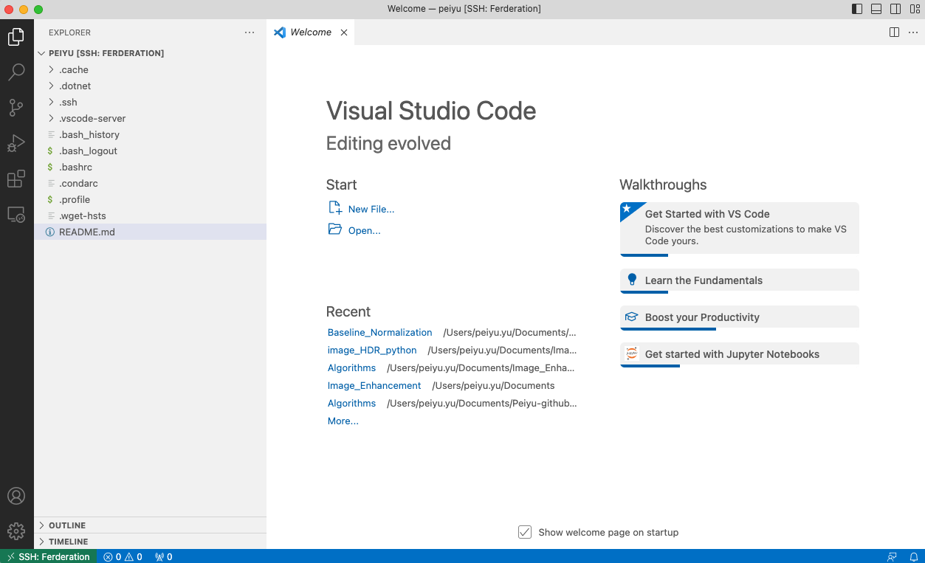

How to install Depthai (to use OAK-D)

1. First install depthai

* Mac M1 Core

bash -c "$(curl -fL <https://docs.luxonis.com/install_depthai.sh>)"

* Mac Intel Core

pip install depthai --no-cache-dir

1. Then install the prerequisites

git clone git@github.com:luxonis/depthai.git

cd depthai

python install_requirements.py

1. Run the demo

python depthai_demo.py